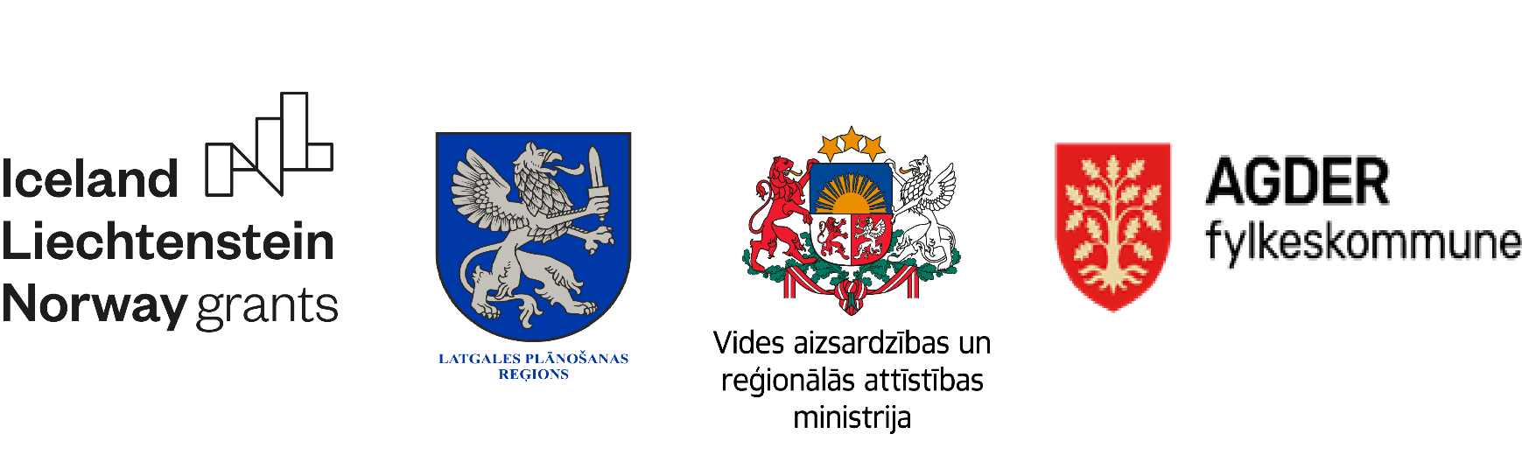
Entrepreneurship support measures in the Latgale Planning Region
Project Applicant: Latgale Planning Region (LPR)
Partners: Ministry of Environmental Protection and Regional Development (MEPRD); Agder County in Norway (AC).

The objective of the Project is to promote local development in the Latgale Planning Region (LPR) by strengthening the capacity of the LPR and its local governments in business issues and implementing measures to promote employment and business capacity.

Total costs of the project: EUR 1 405 964; costs of LPR - EUR 1 114 405
The target groups are LPR, local governments, entrepreneurs, non-governmental organizations, including organizations representing employees, trade unions, young people and natural persons.
Project realisation time: 24.05.2021. - 23.04.2024
Main activities:
1. Strengthening the capacity of the LPR Business Centre and local governments;
The objective of the activity is to activate local resources and local partnerships between economic operators, local government institutions, the financial sector and the non-governmental sector in order to promote business and increase the level of development of the Latgale Region. The main activity is aimed at improving the business support system in the Latgale Region. The capacity building of Latgale Business Centre (LBC) and local governments shall be carried out by attracting two qualified business specialists, as well as strengthening the technical capacity of LBC. Seminars and discussions shall be organized on topics that strengthen the capacity of local government employees, their ability to independently provide advisory support on the creation and development of competitive business, new forms of business models for commercialization of ideas, risk management in business, creative thinking methods for business idea development, investment attraction, innovation support mechanisms and other issues. It is planned to attract the Norwegian partners for the implementation of seminars and trainings. In its turn, in order to more efficiently handle the development planning of the Latgale Region, the Project Partner MEPRD shall evaluate the potential of socio-economic development of the region, as well as develop recommendations for future support mechanisms for promoting socio-economic development of territories in special economic zones in Latgale.

2. Activities for promoting Latgale region;
The objective of the activity is to popularize the Latgale Region as an attractive place for business and strengthen the region's business potential. The main attention of the activity shall be focused on the promotion of LPR and the Latgale local government business on a local and international scale, organizing awareness-raising events and participating in investment promotion events abroad. The activity shall include the organization of the Latgale Days in Riga, events at the Latgale Representative Office in Riga, LPR participation in investment forums abroad, the creation of the Latgale Region video presentation and other awareness-raising events.
3. Regional youth business mentoring
The objective of the activity is to promote the increase of business competitiveness, motivate young people to integrate into the labour market and take steps to start their own business. The youth-mentoring activities shall include thematic business motivation activities and camps, during which young people would develop communication and initiative skills and gain knowledge for starting a business, by attracting experienced mentors. In the framework of activity several sub-activities are planned. For example, youth entrepreneurship camps, discussions about entrepreneurship amongst the youth.

4. Support for increasing employment and competitiveness through the region-specific activities.

The objective of the activity is to increase employment opportunities in the region and strengthen the competitiveness of the Latgale Region. Within the framework of the activity, informative seminars shall be organized for existing and future economic operators in order to provide knowledge, share experience on business development and competitiveness issues. Within the training process, the most successful participants shall be motivated / supported to do business in the Latgale Region in developing new and region-specific ideas. In order to promote employment and increase competitiveness, it is planned to develop and implement a region-specific solution - interest education programmes in the field of business. Strengthening business education among children and young people shall have a positive impact on the dynamics of the business environment in the region's economy. Programmes shall be developed for 4 age groups: preschool children, children of grades 1-4, children of the grades 5-9 and youth of the grades 10-12. The main focus of the Norwegian partners shall be on the development of the program for the youth of the grades 10-12.

5. Publicity
The activity will promote the visibility of the European Economic Area financial instrument and the role of Norwegian partners in achieving the project goal and program objectives, informing the public and project target groups about the content and benefits of project activities. For example, the public will be informed through local and national media, project related videos, information about the activity will be provided on LPR, MEPRD and ARP websites, a user profile will be created and maintained on the social network ''Facebook''.

